Computing evidence Year 4

Creating a website

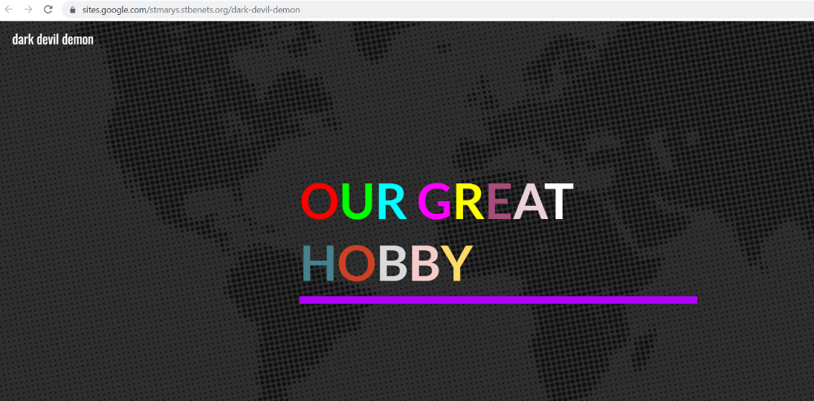
Day one – learning how to access Google sites and make a simple homepage:

Day two – learning how to create a book review on Google sites, and embed images:
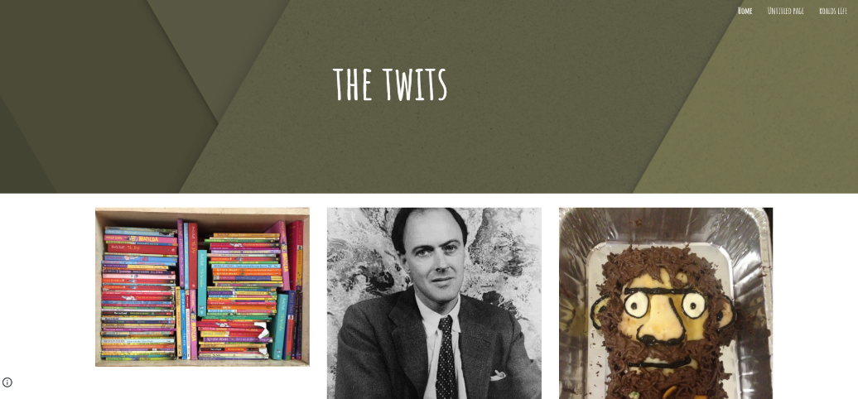

Day three – planning a website, a colour theme, learning how to create extra pages and reflecting on our learning so far:
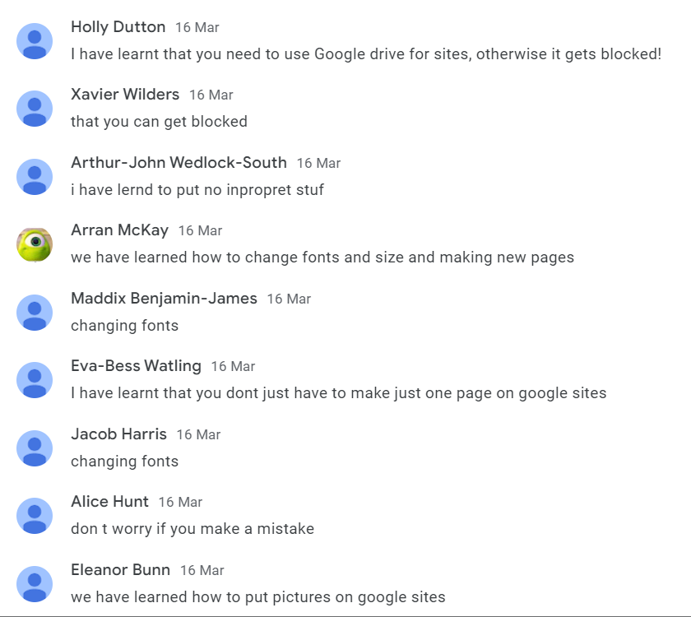
Day four – we were challenged to create a school website that was more impressive than the real one!

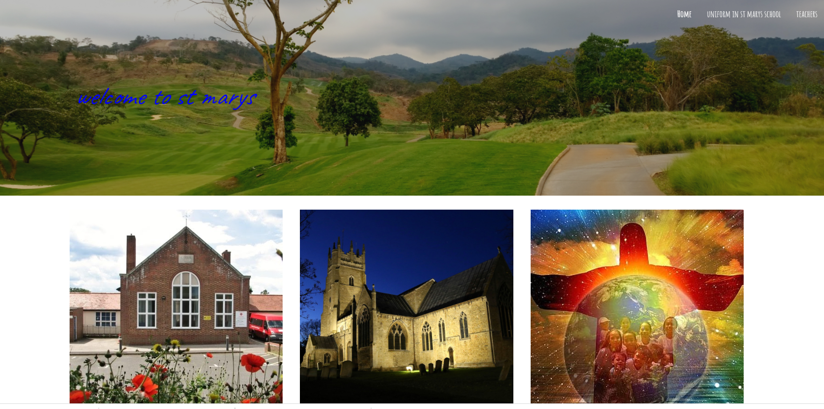

Day five – creating and evaluating our own final website, including embedded YouTube videos, links to other websites, text, images and three sub-pages:

