English:
Odysseus - Adventure narrative and choral stanzas

Modal verbs and assertions / questions used for headings / expanded noun phrases / powerful verbs / empty words / adjectives / short action sentences / emotive language
Maths:
Statistics convert between different units of measure [for example, kilometre to metre; hour to minute] interpret and present discrete and continuous data using appropriate graphical methods, including bar charts and time graphs, solve comparison, sum and difference problems using information presented in bar charts, pictograms, tables and other graphs
Geometry – angles and 2D shapes, position and direction draw 2-D shapes and make 3-D shapes using modelling materials; recognise 3-D shapes in different orientations ,compare and classify geometric shapes, including quadrilaterals and triangles, based on their properties and sizes, complete a simple symmetric figure with respect to a specific line of symmetry
Mass and Capacitymeasure, compare, add and subtract: lengths (m/cm/mm); mass (kg/g); volume/capacity (l/ml)

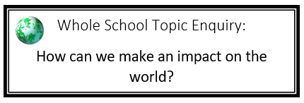

Y3/4 Summer 2
St Mary’s – Cycle B

Science:
Forces and magnets
Pushes and pulls
Gravity and friction
What different magnets look like
How magnets react to each other
How to investigate whether a material is magnetic
How magnets are used in real-life
History:
Ancient Greeks
First Greek civilizations
Life in classical Greece.
Different city-states – including Athens and Sparta.
Greek democracy
The Olympics,
Greek philosophers

PSHE:
Changing me
Understanding the changes between conception and growing up, how babies grow and develop, how our bodies need to change and the inside and outside to be able to make babies in the future.

Music:
Reflect, rewind, replay
Listen to and appraise classical music whilst embedding the foundations of the interrelated dimensions of music.
DT:
Structure – Pavilions
Designing and making a pavilion through exploration of structure, frames and cladding.
Computing/ICT:
Data handling – gathering information and processing it to create databases.
Online safety – developing our understanding of being responsible and safe online
RE:
The Big Question: What difference does being a Muslim make to daily life?

PE: Athletics Develop basic running, throwing and catching techniques and use these techniques to complete set challenges.

Trip/ Visitor:
Ancient Greek day in school
Modern Foreign Language:
French shopping – using money and asking to buy items

